**Customer – Usage Guide**

1. Log In Page

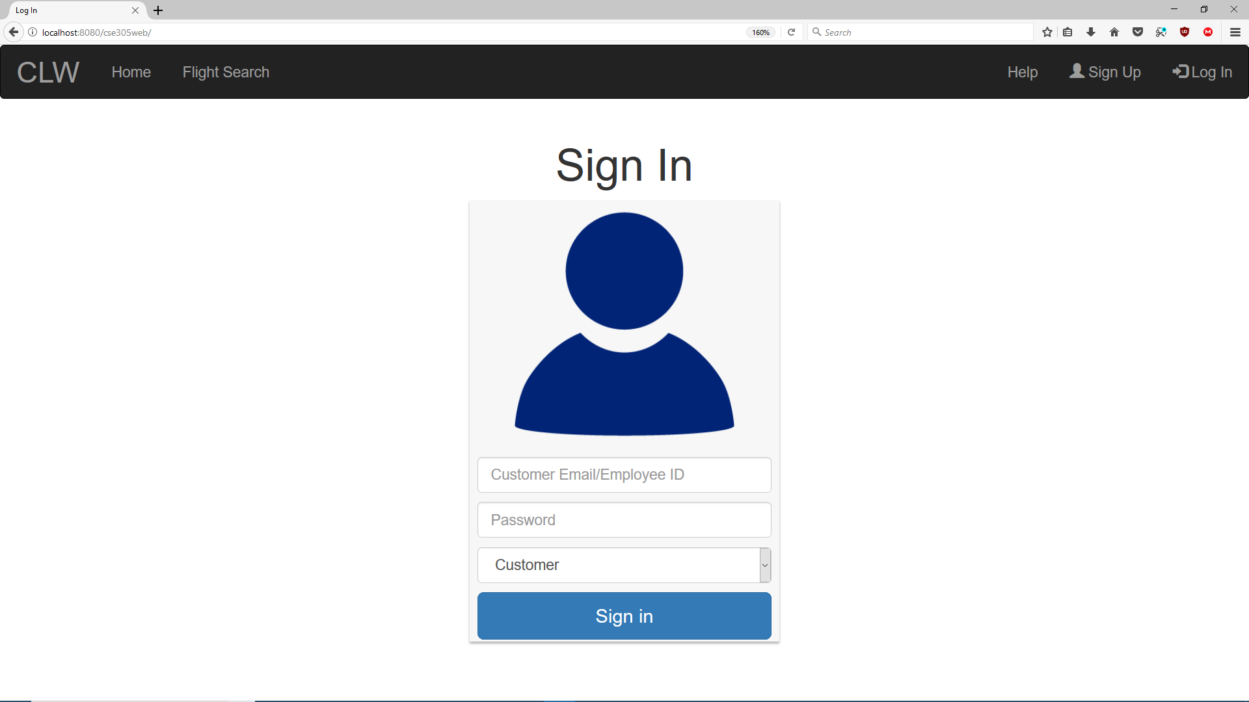

9

8

7

6

5

4

3

2

1

Navigation Bar

1. Go to the home page.

2. Go to a search page for flights.

3. Go to a comprehensive help page.

4. Sign up as a new customer.

5. Log in with credentials.

Sign In

6. Enter the email associated with your account.

7. Enter the password associated with your account.

8. Select Customer in the drop-down menu.

9. Click to authenticate and sign in with your credentials.

2. Sign Up Page

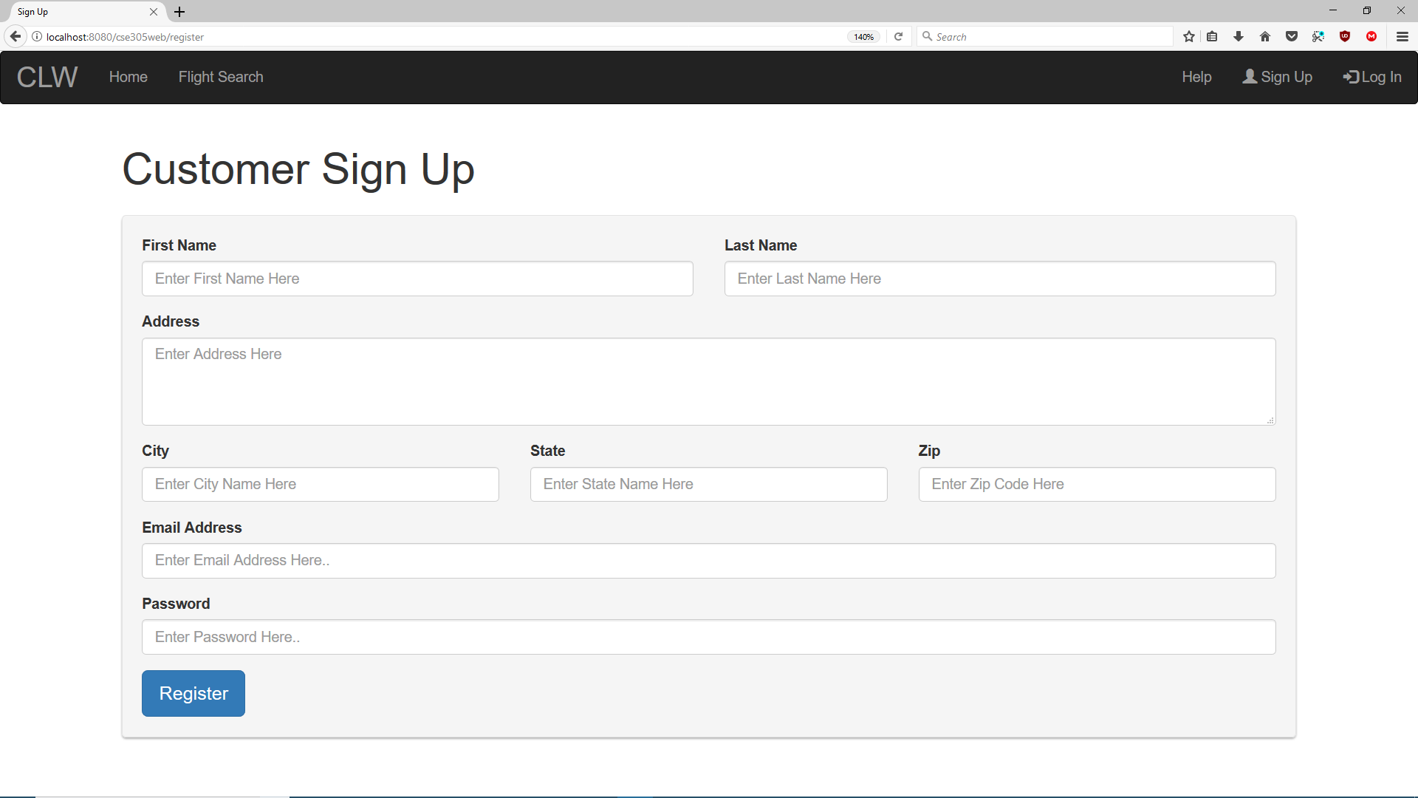

2

1

1. Fill in all fields as directed on the website.

2. Click to register your account.

3. Customer Profile Page

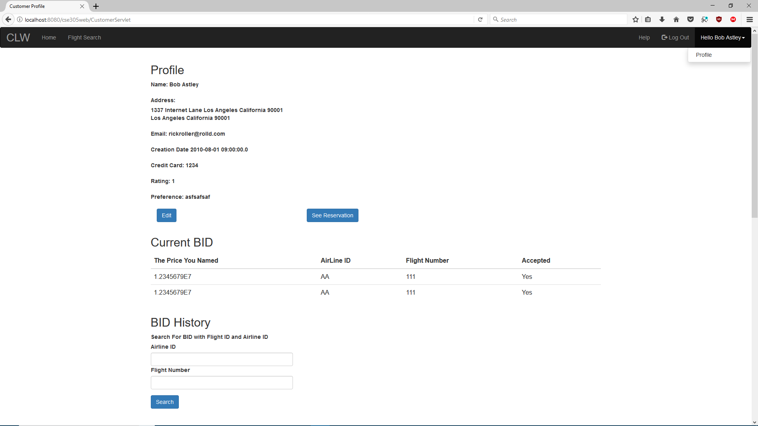

6

5

4

3

2

1

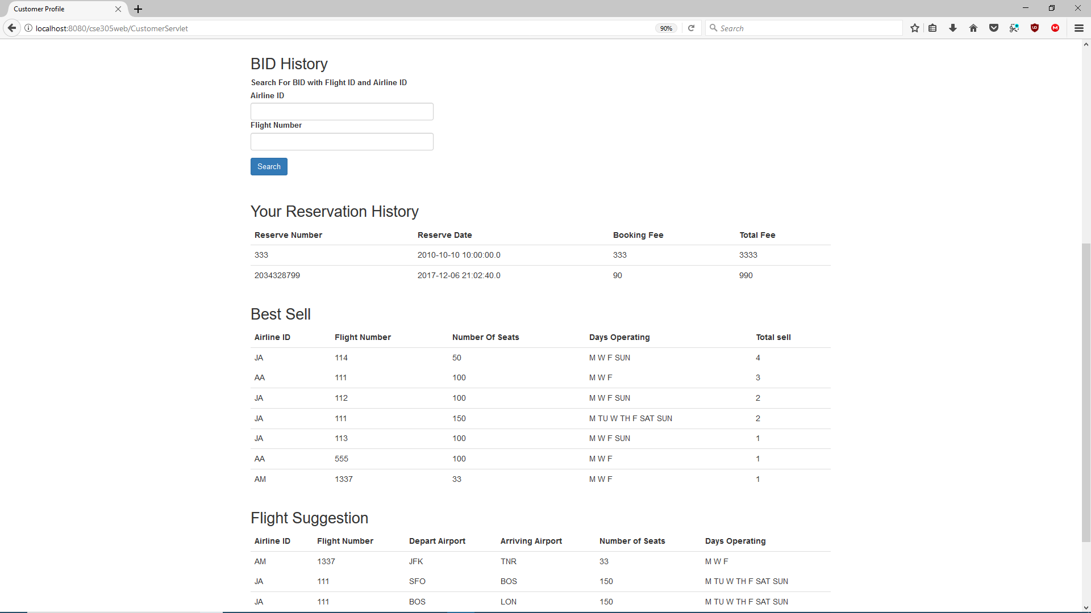

9

8

7

Navigation Bar

1. Click to log out of your account.

2. Click to go to your profile.

Profile Page

3. See and edit your profile information.

4. See your current reservations.

5. See your current reverse auction bids.

6. Fill in the form to see your past reverse auction bids.

7. See your past reservations.

8. See a list of best sell flights.

9. See a list of flight suggestions tailored to you.

4. Update Your Profile

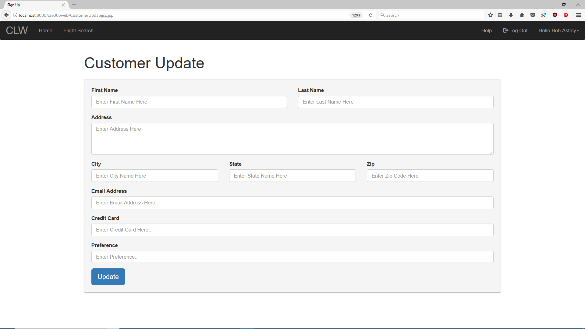

2

1

1. Fill in the fields as directed.

2. Click to update your profile as needed.

5. Current Reservations Page

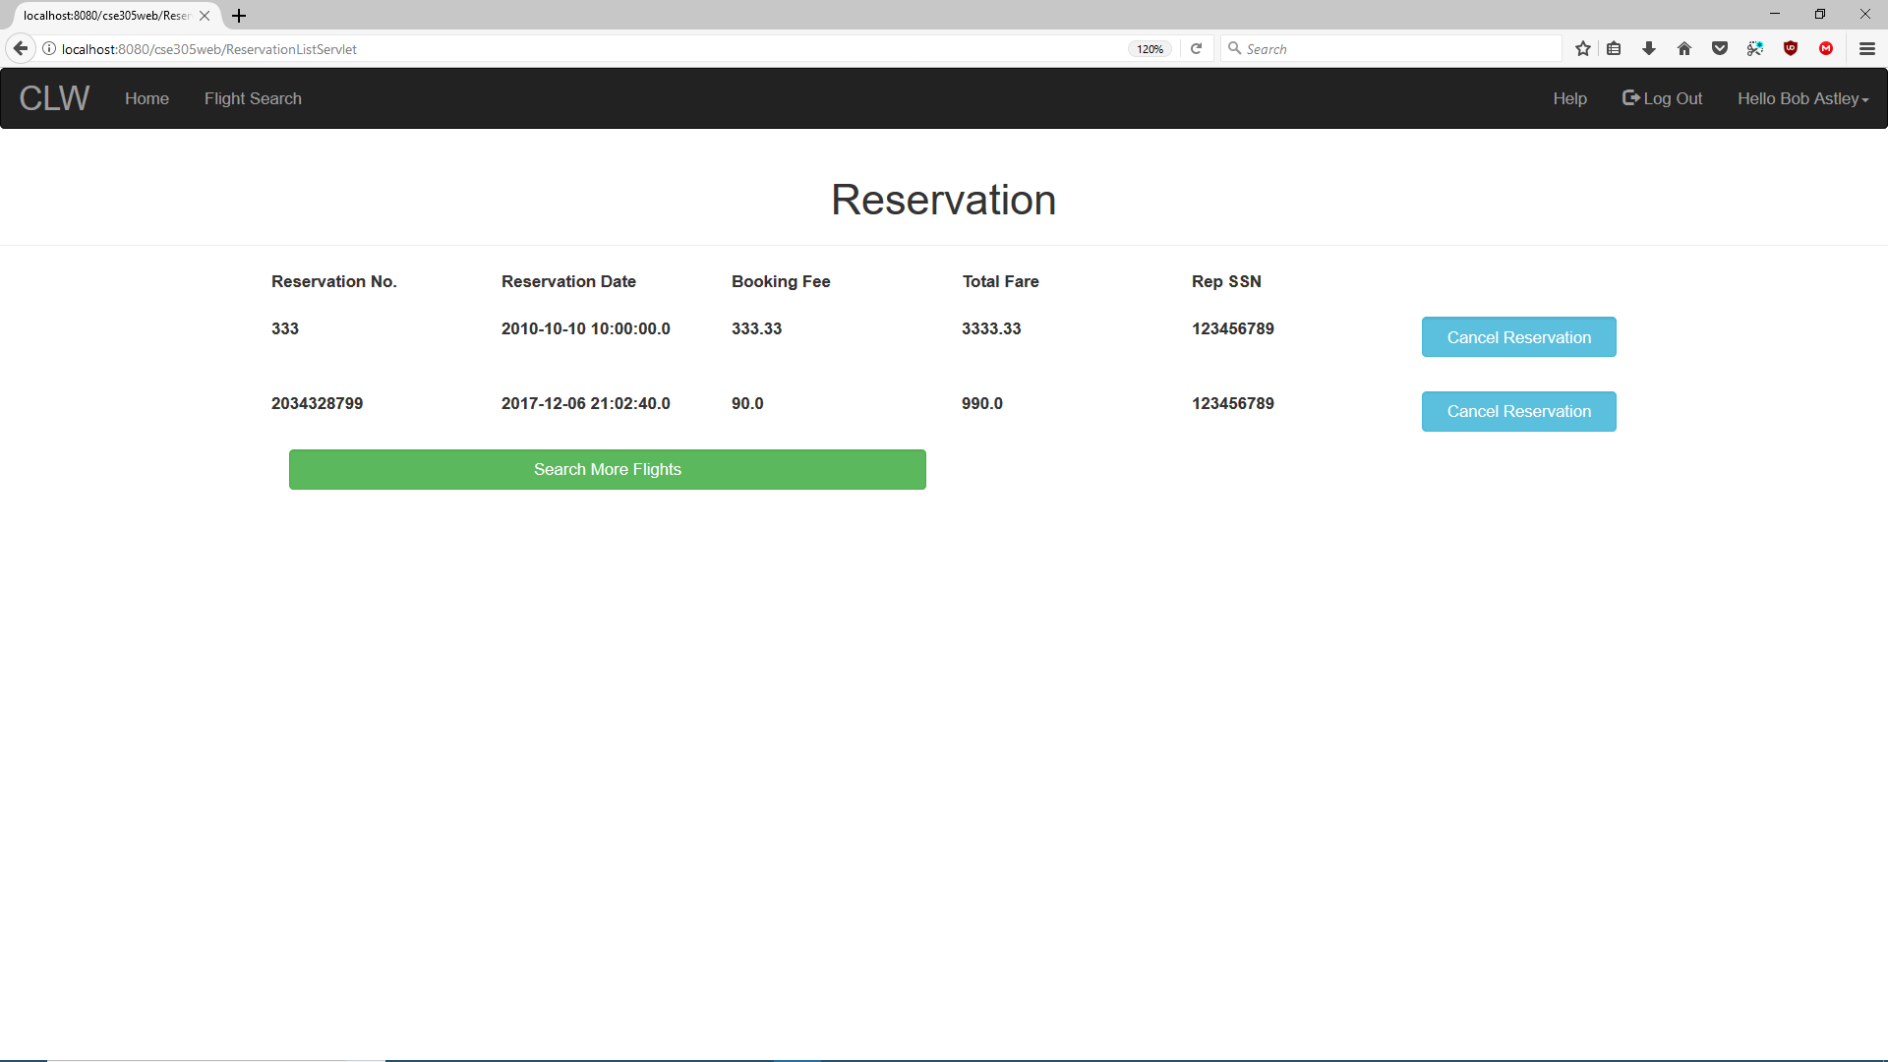

3

2

1

1. See your current reservations.

2. Click to go search for more flights to reserve.

3. Click to cancel current reservation.

6. Flight Search Page

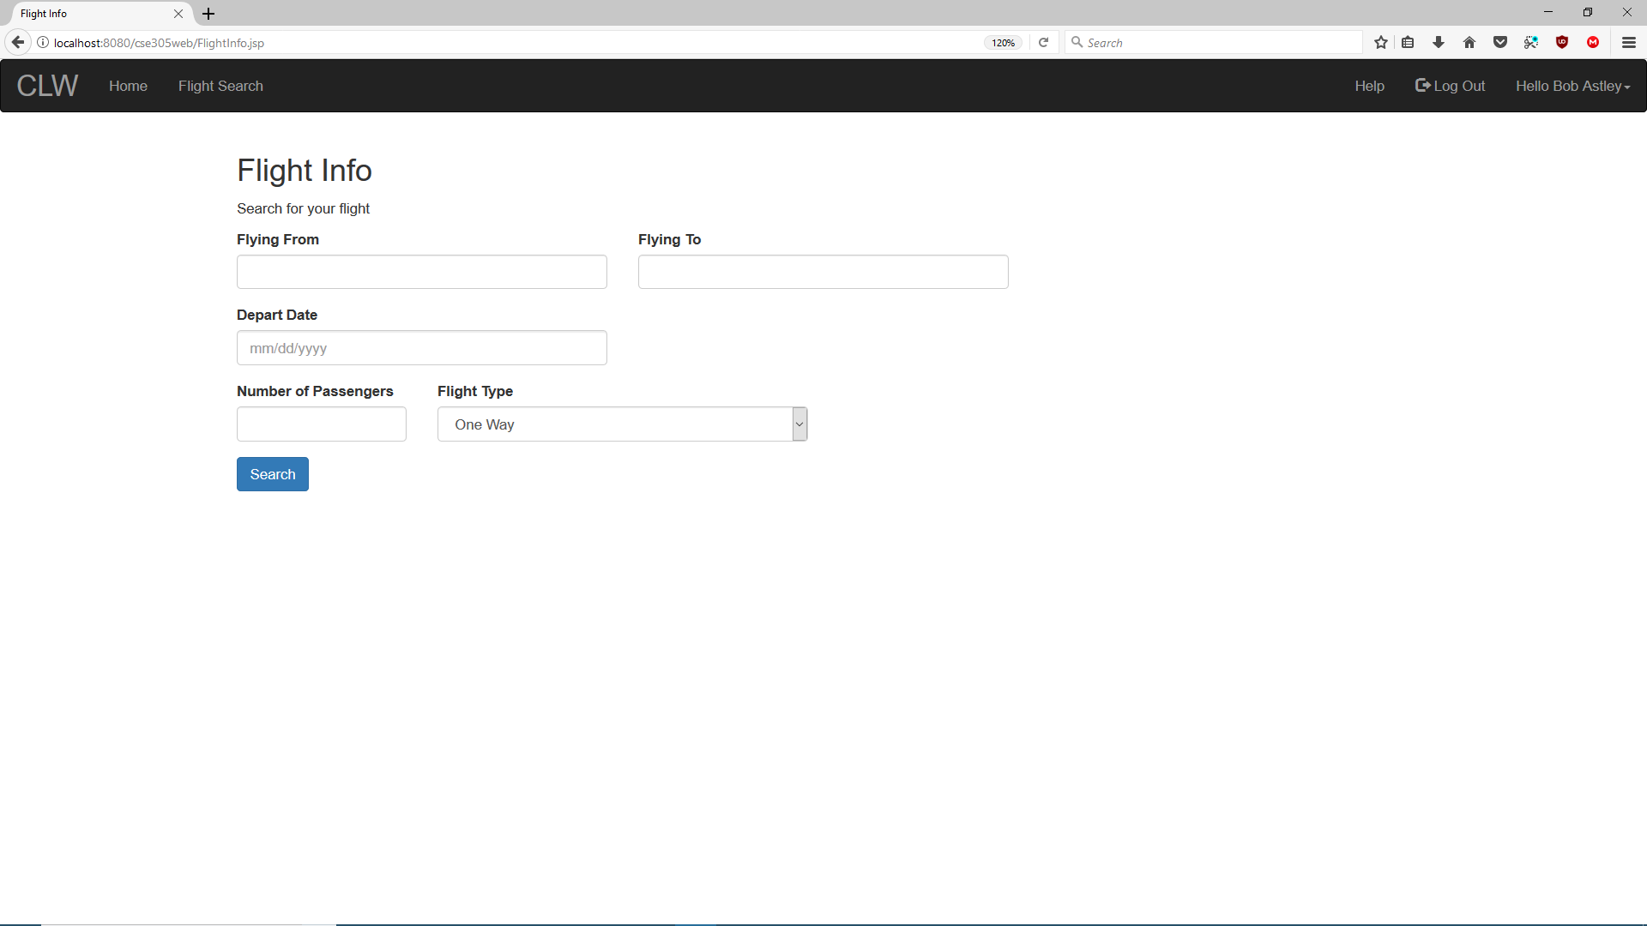

2

1

1. Fill in the fields as directed. You can choose different flight types.

2. Click to search for flights based on your criteria.

7. Flight Info Page

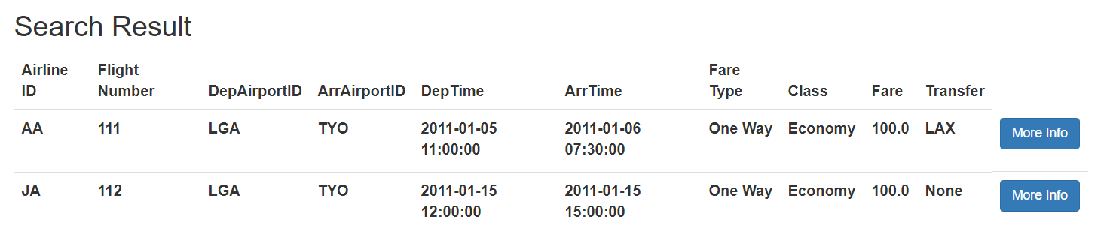

2

1

1. See the list of flights based on your search criteria.

2. Click to see more info on the flight and to reserve/bid on.

8. More Flight Info Page

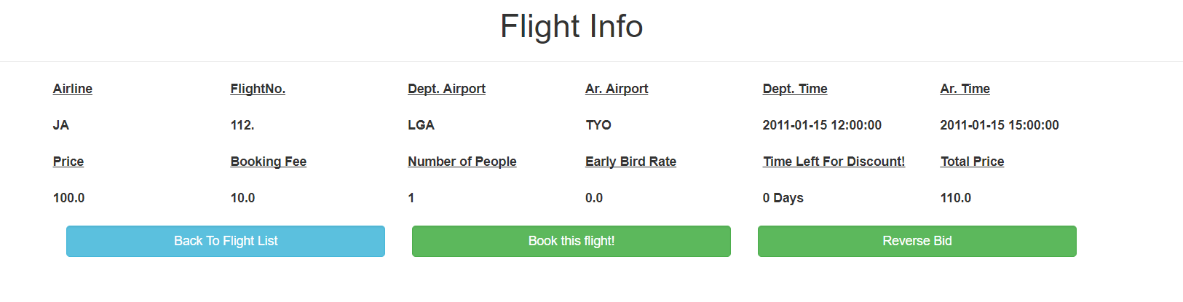

4

3

2

1

1. See the extra flight info for your chosen flight.

2. Click to go back to search for more flights.

3. Click to reserve the current flight.

4. Click to reverse bid the current flight.

9. Reserve Flight

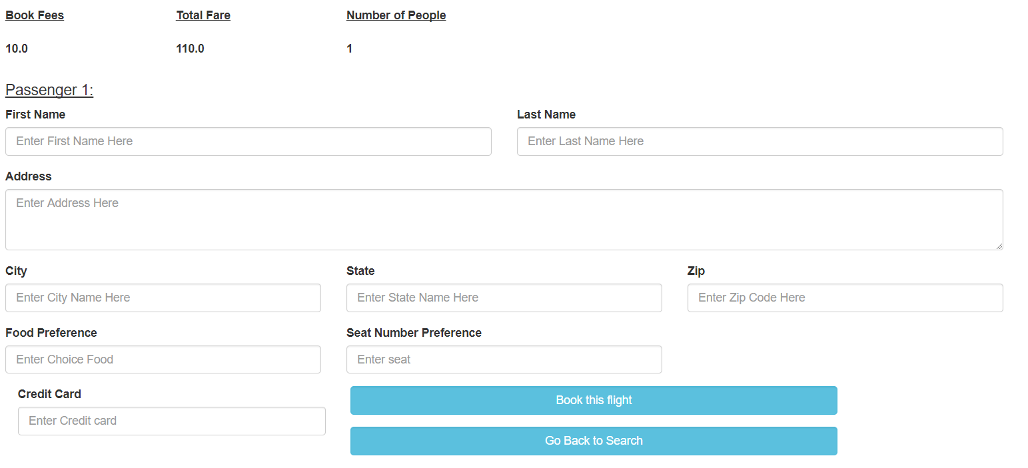

3

2

1

1. Fill in fields as directed.

2. Click to reserve flight.

3. Click to go search for more flights.

10. Reverse Bid Flight

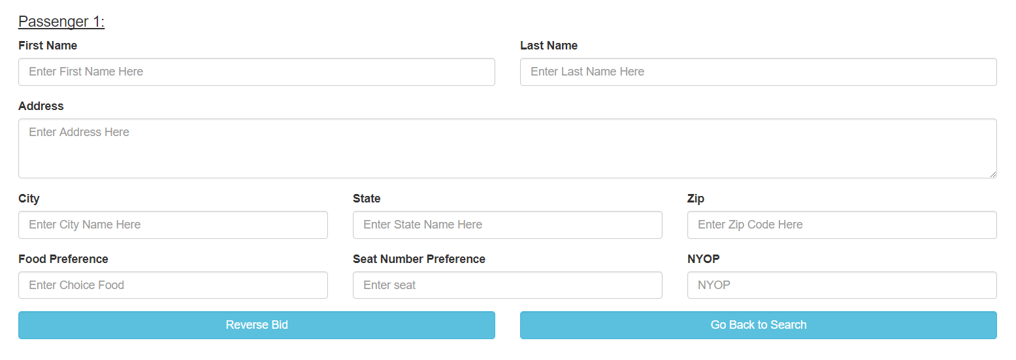

2

3

1

1. Fill in fields as directed.

2. Click to place a reverse bid.

3. Click to go search for more flights.

**Employee – Usage Guide**

1. Log In Page

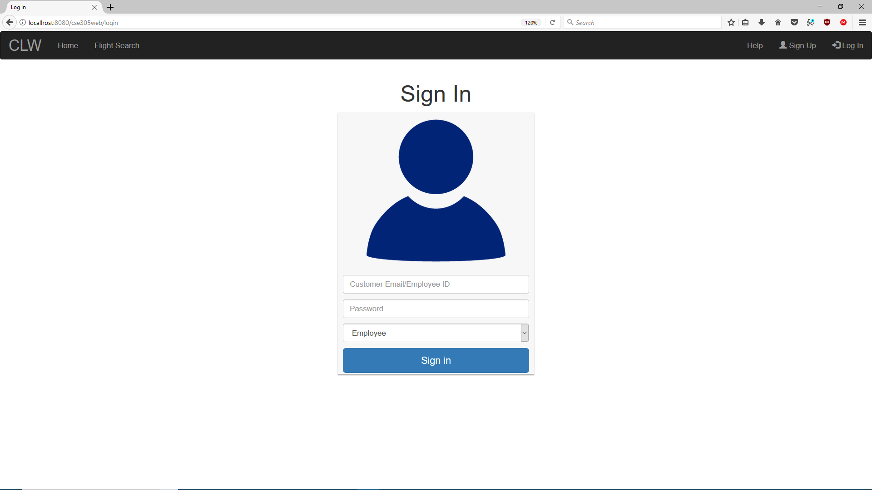

4

3

2

1

1. Enter your employee id.

2. Enter your password which is your employee id.

3. Select Employee in the drop-down menu.

4. Click to authenticate and sign in with your credentials.

*Note- Please see Customer Log In Page for information on Navigation Bar.

2. Employee Profile

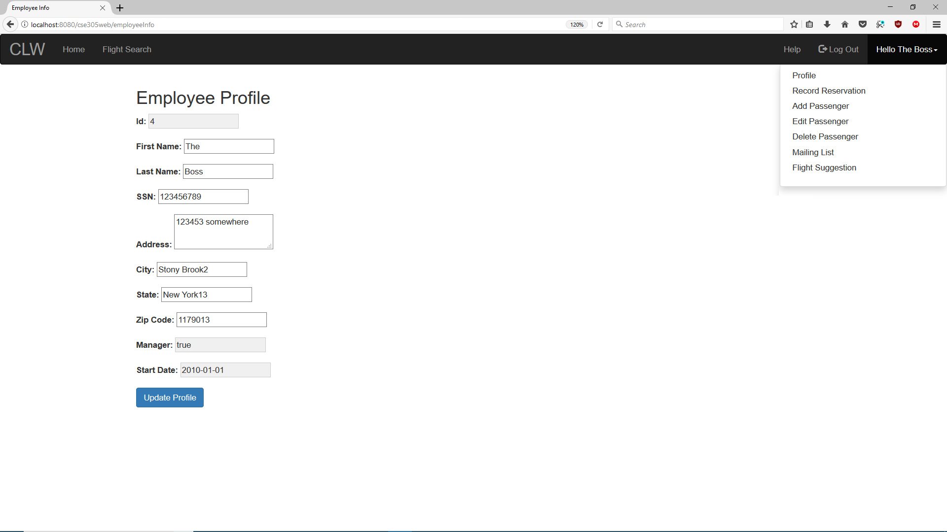

2

1

1. You can see and update your profile.

2. You have a list of actions that you can do which are record reservation, add/edit/delete passenger, produce mailing list, and produce flight suggestion.

3. Record Reservation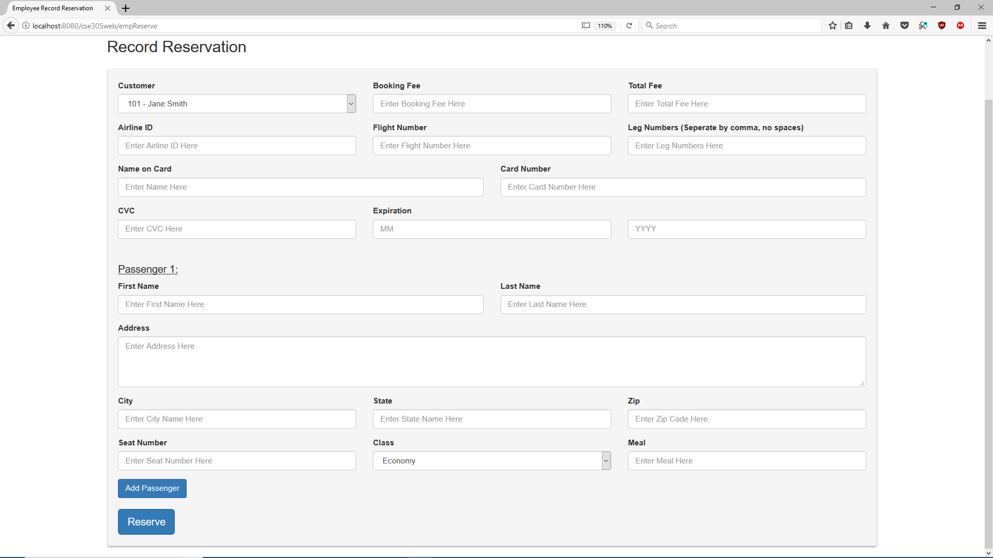

3

2

1

1. Fill in fields as directed.

2. Add an extra passenger and fill in fields as needed.

3. Record the reservation.

4. Add Passenger

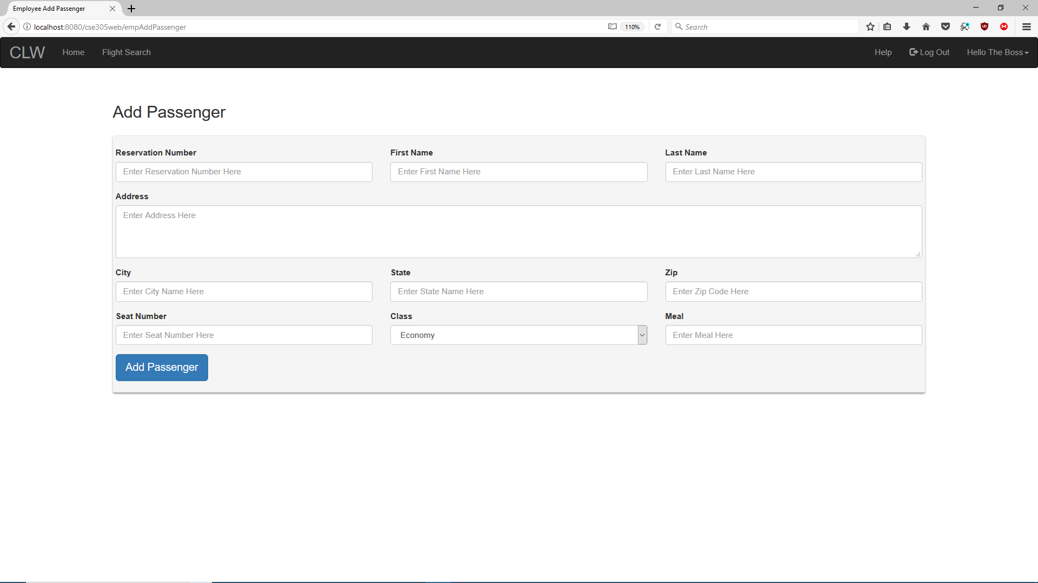

2

1

1. Fill in fields as directed and needed.

2. Click to add passenger to chosen reservation.

5. Edit Passenger

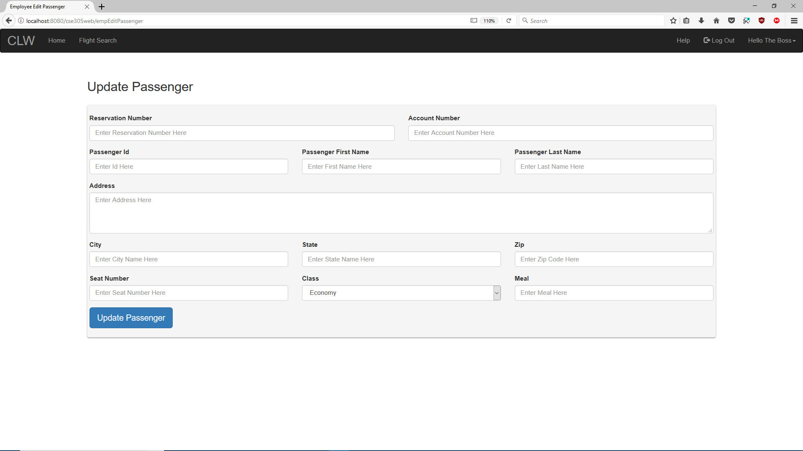

2

1

1. Fill in fields as directed.

2. Click to update passenger information.

6. Delete Passenger

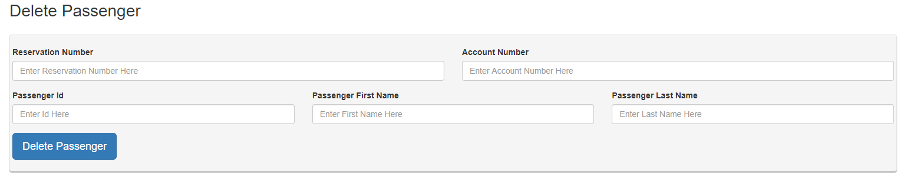

2

1

1. Fill in fields as directed

2. Click to delete passenger from reservation.

7. Produce Customer Mailing List

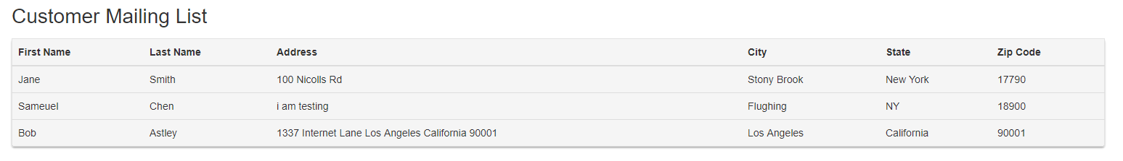

1

1. See the generated customer mailing list.

8. Produce Flight Suggestions

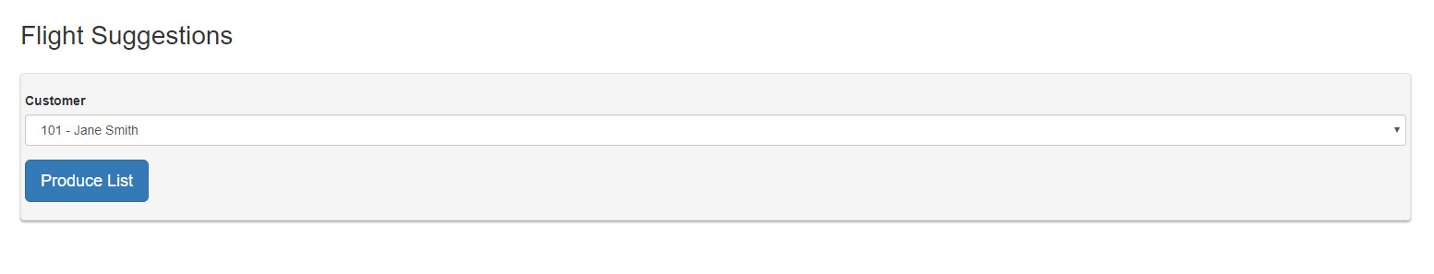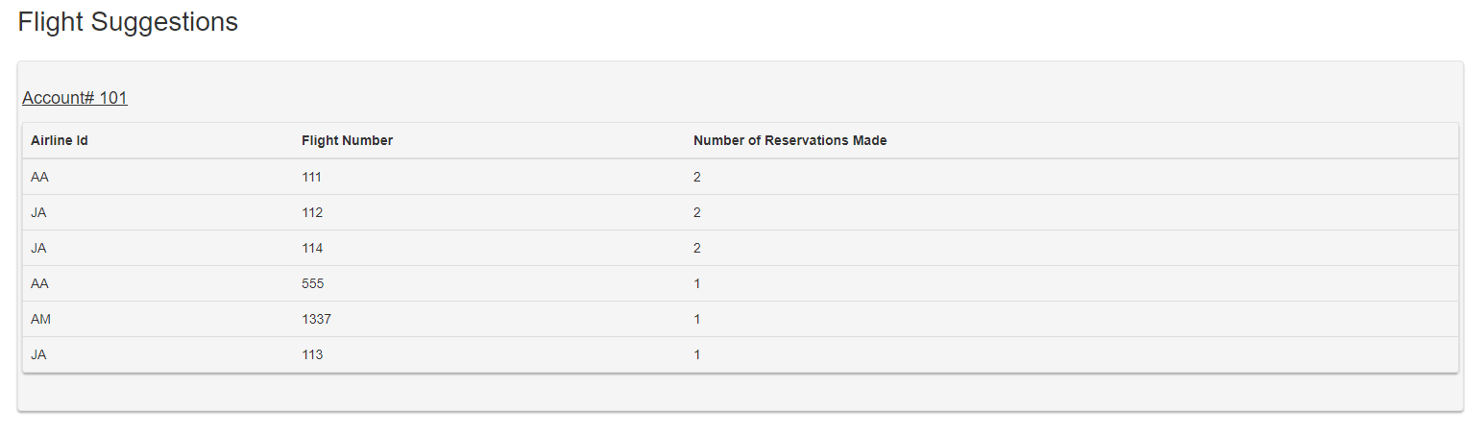

2

1

1. Select the customer from the drop-down menu and click Produce List.

2. See the flight suggestions for the selected customer.

**Manager – Usage Guide**

A manager can do all the transactions that the employee can do as well.

1. Extra Actions in Navigation Bar

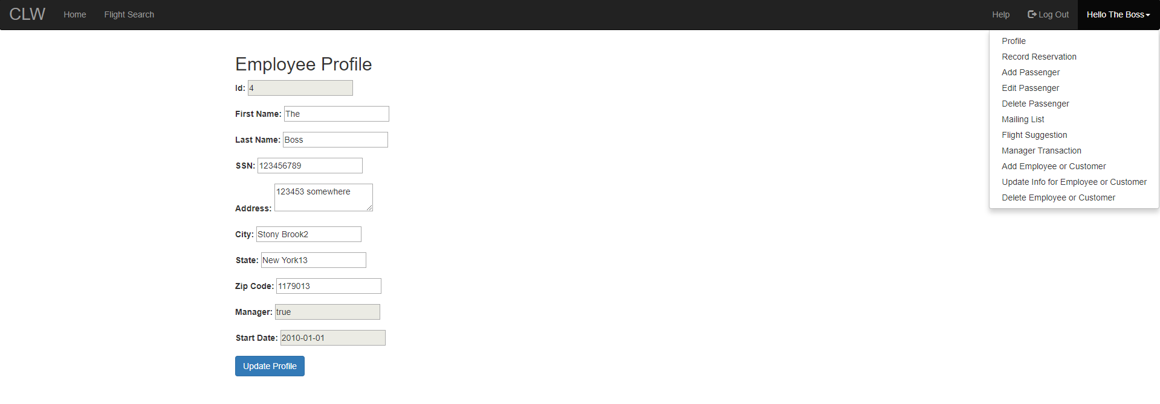

1

1. In addition to the employee actions, a Manager can perform manager transactions, and adding/editing/updating employee or customer.

2. Manager Transactions

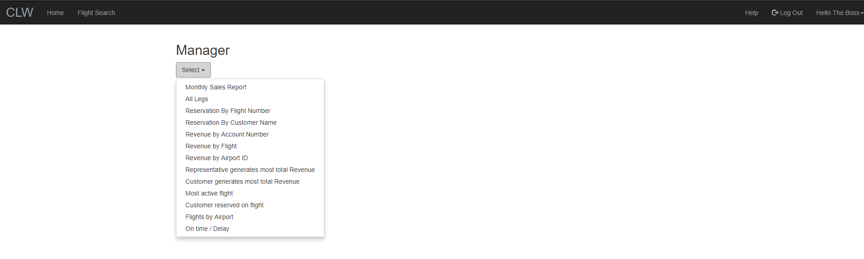

1

1. These are all the transactions that a manager can perform on this page.

3. Manager Transaction – Monthly Sales Report

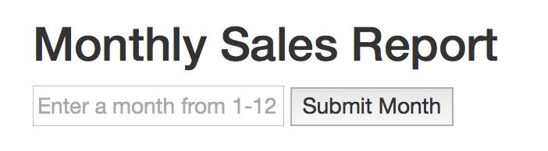

1

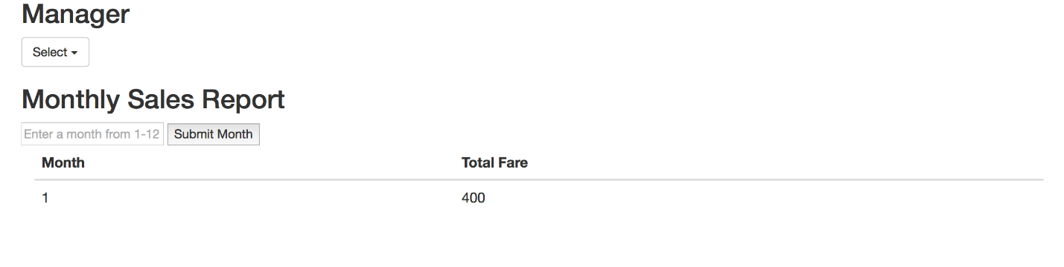

2

1. Enter a month from 1 to 12 to view the sales.

2. You see the generated monthly sales report based on the month specified.

4. Manager Transaction – All Legs

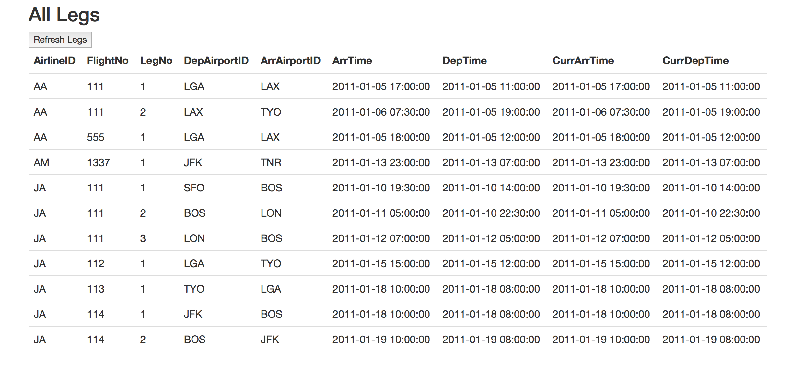

1

1. Click Refresh Legs button to display all the legs.

5. Manager Transaction – Reservation By Flight Number

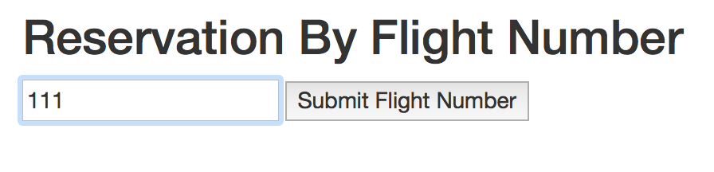

1

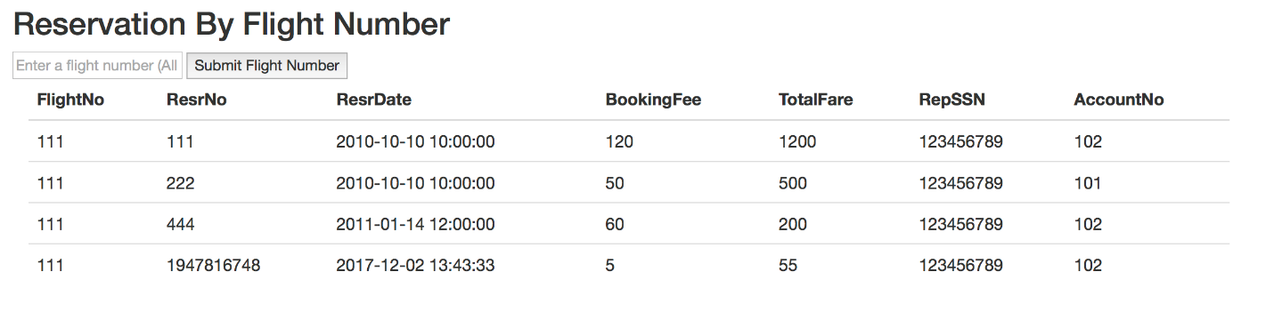

2

1. Input the flight number to see all reservations containing that flight number.

2. See the list of reservations generated.

6. Manager Transaction – Reservation By Customer Name

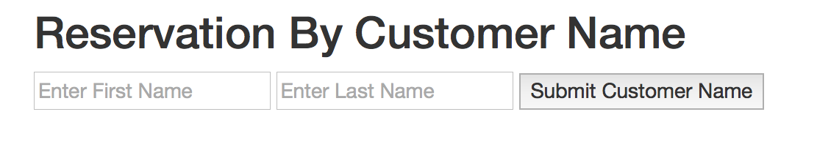

1

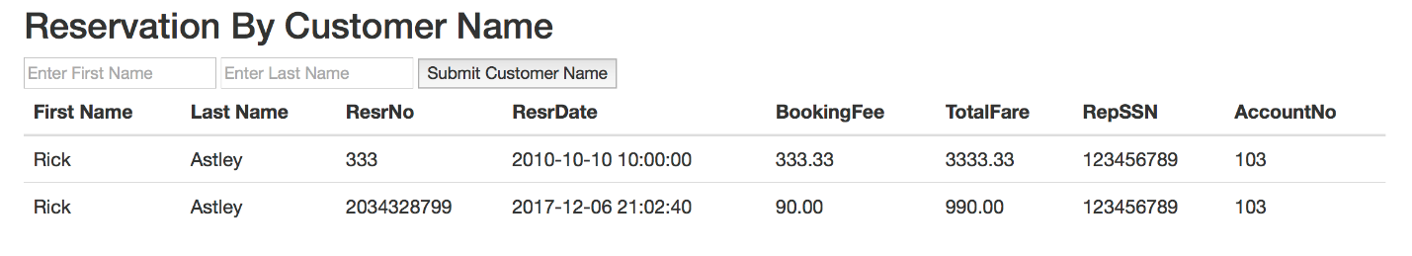

2

1. Input first and last name of customer.

2. See list of reservations based on inputted customer name.

7. Manager Transaction – Revenue By Account Number

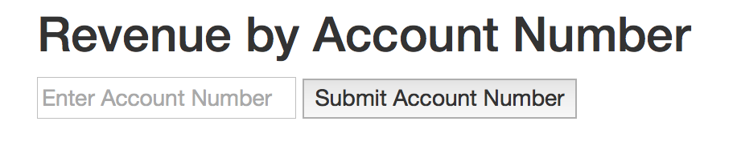

1

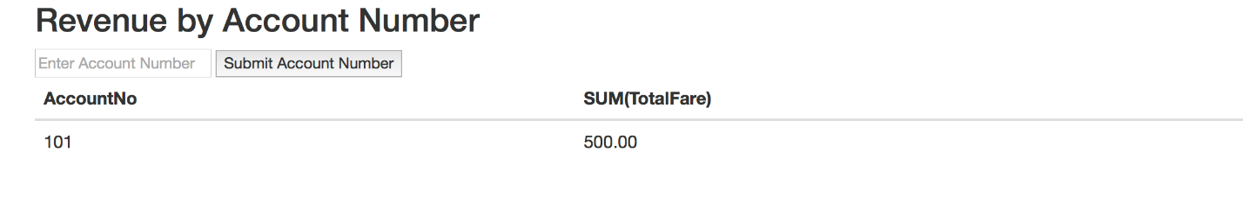

2

1. Enter customer account number.

2. See the revenue generated by specified account number.

8. Manager Transaction – Revenue By Flight

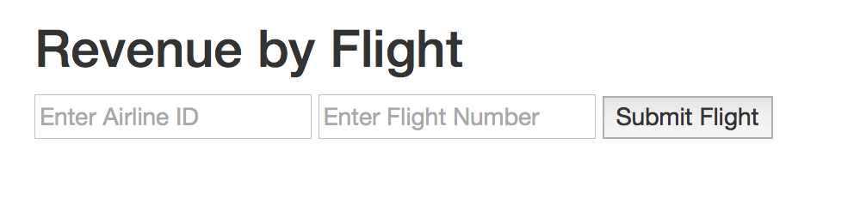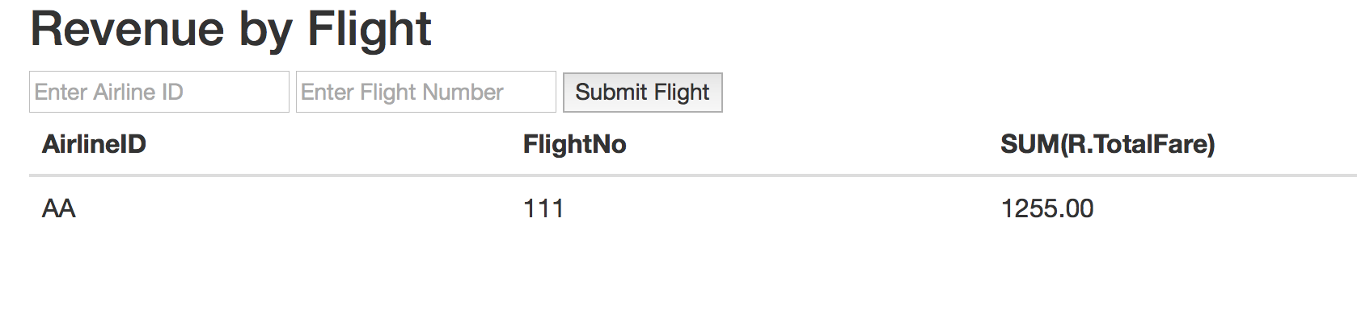

2

1

1. Enter the airline id and flight number of particular flight.

2. See the revenue generated by the specified flight.

9. Manager Transaction – Revenue By Airport Id

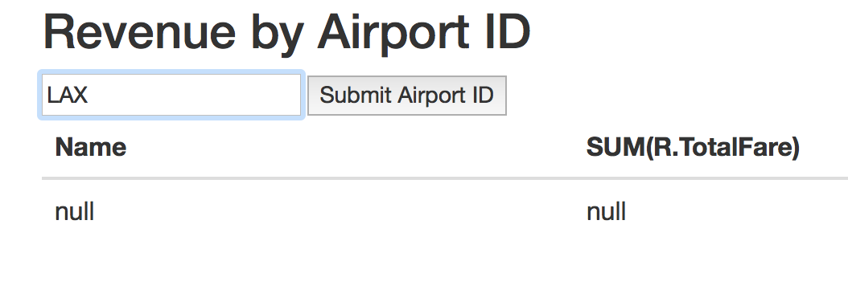

1

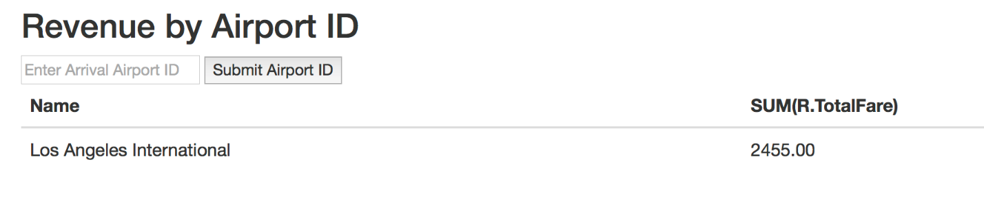

2

1. Enter the Airport ID.

2. See the revenue generated by the specified airport id.

10. Manager Transactions – Total Revenue By Representative/Customer

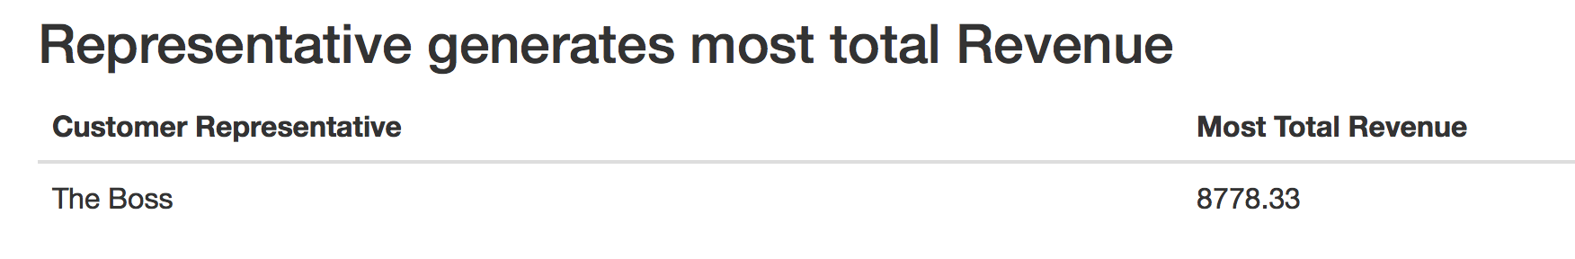

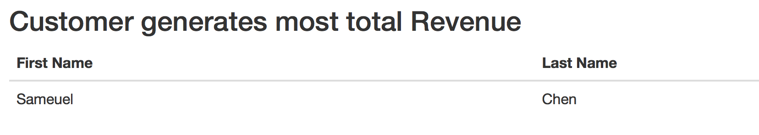

1. You can see who generated the most total revenue, by customer representative or customer.

11. Manager Transaction – Most Active Flight

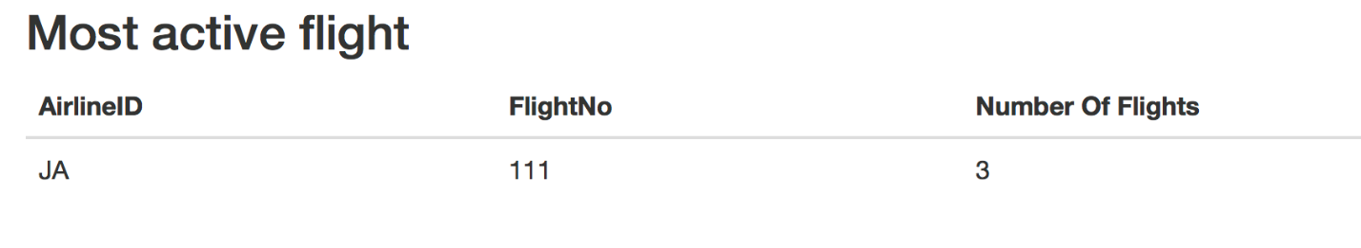

1. You can see the most active flight currently.

12. Manager Transaction – Customer Reserved on Flight

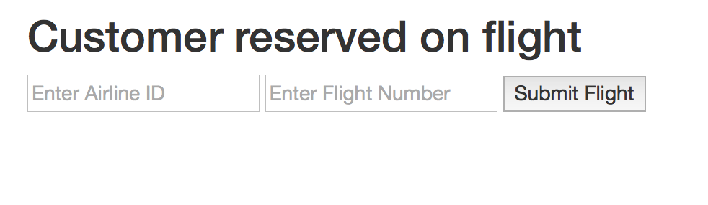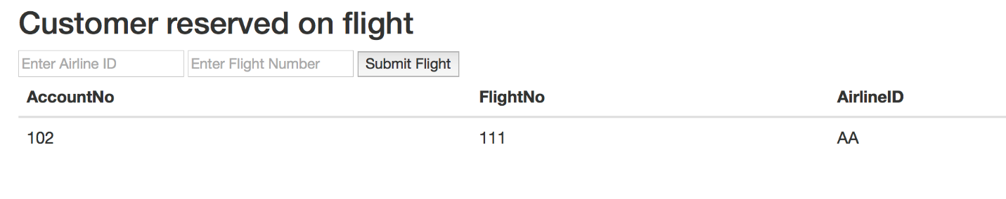

2

1

1. Enter airline id and flight number of a specific flight.

2. See customer reserved on that specified flight.

13. Manager Transaction – Flights By Airport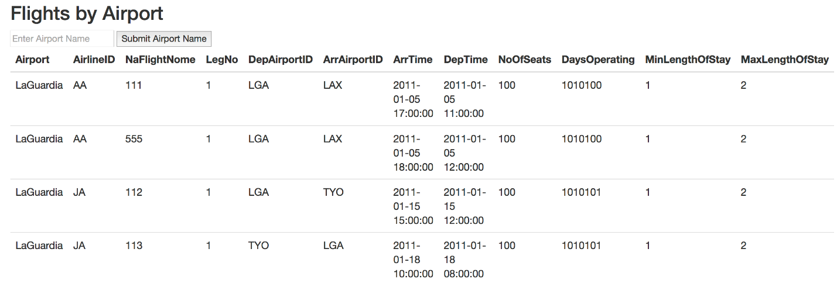

1. You can see the generated list of flights based on the airport inputted.

14. Manager Transaction – On time/delayed flights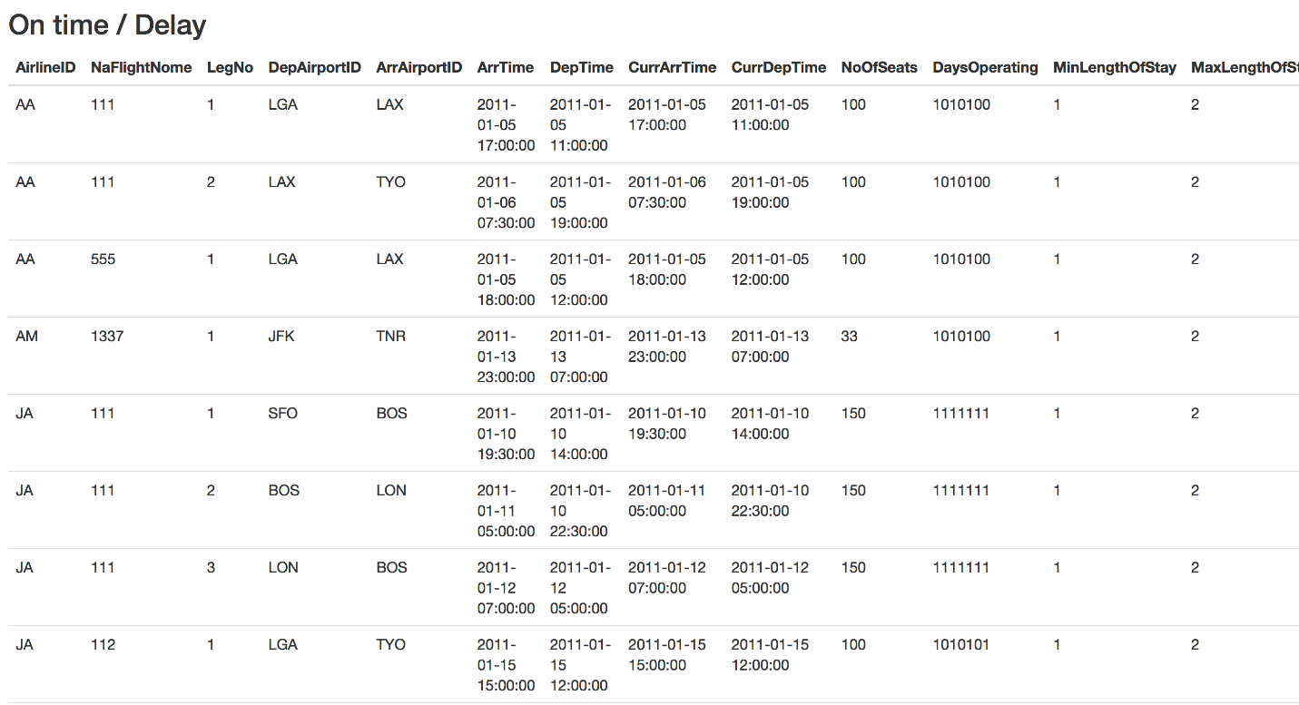

1. You can see the list of all flights that are on time and delayed.

15. Manager Edit Page

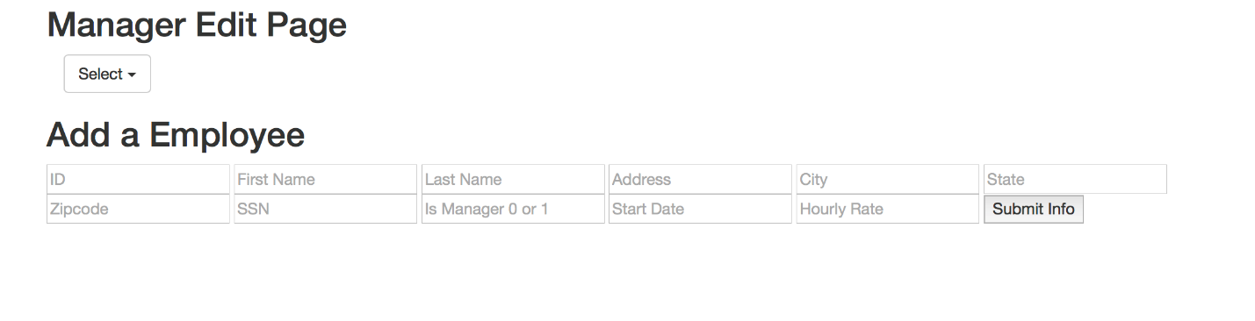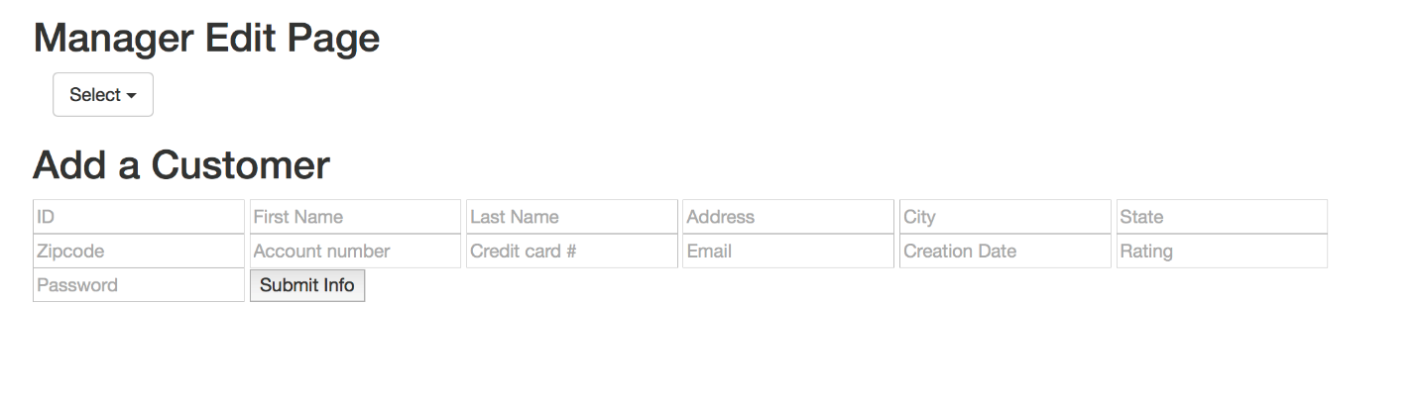

1. You can either add an employee or customer by filling in the fields needed.

16. Manager Update Page

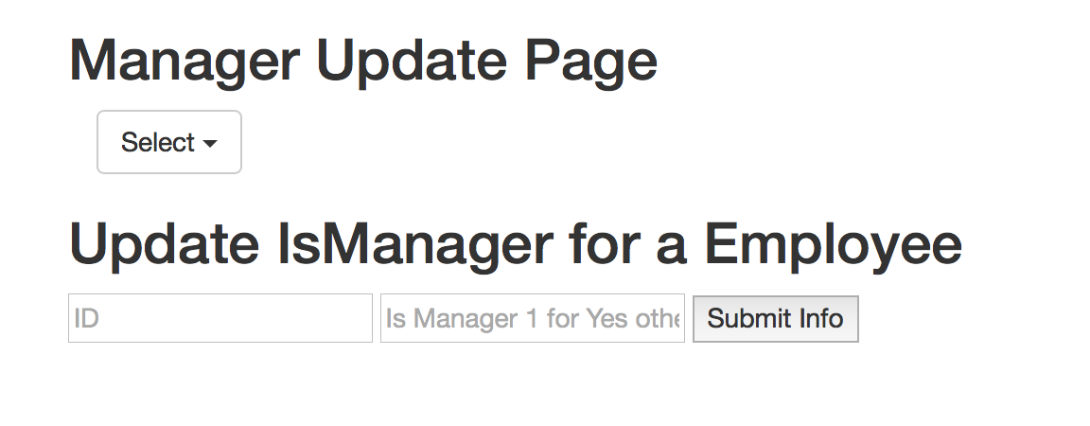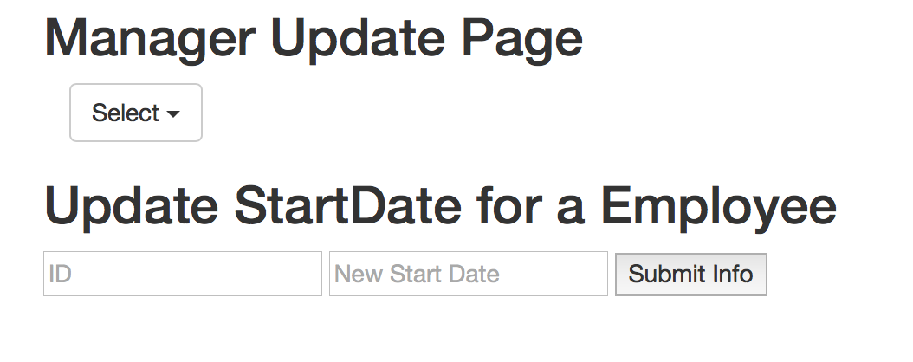

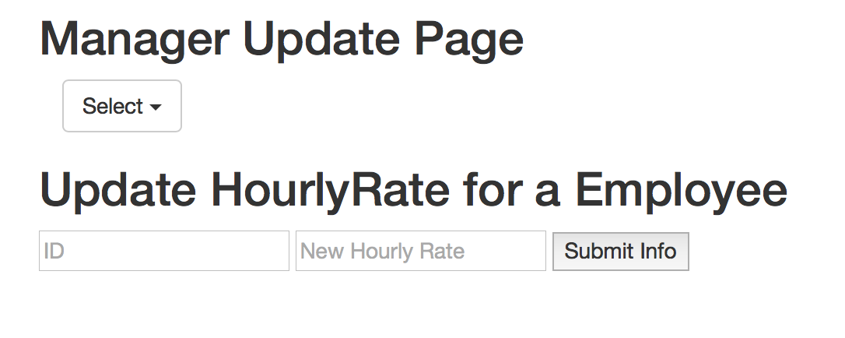

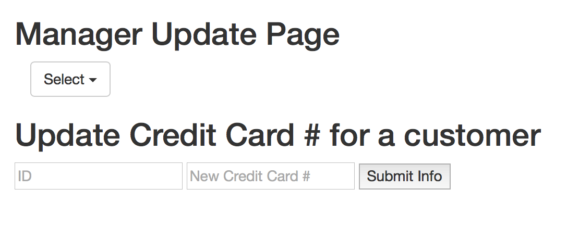

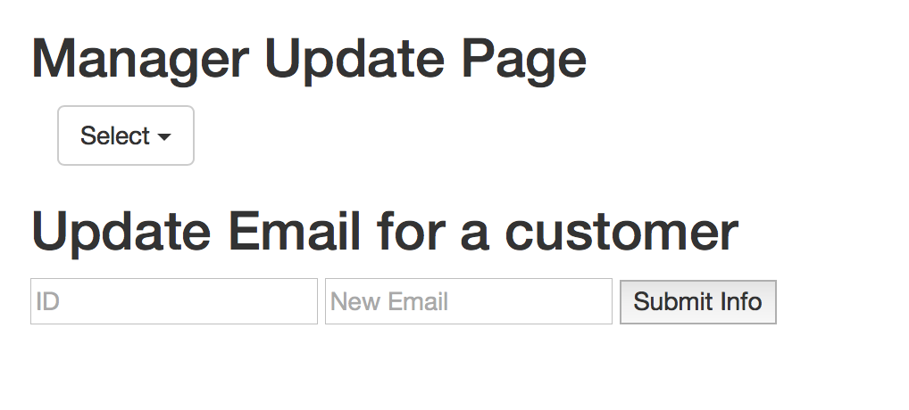

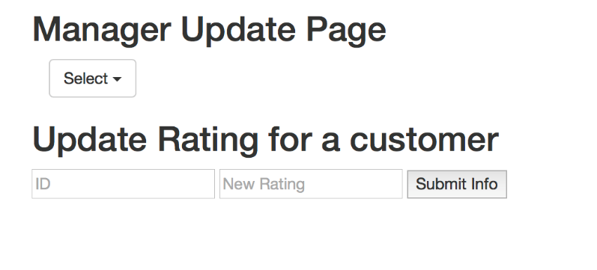

1. You can make an employee a manager, change the start date and hourly rate of an employee, and change the credit card number, email, and rating for a customer.

17. Manager Delete Page

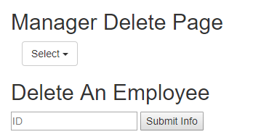

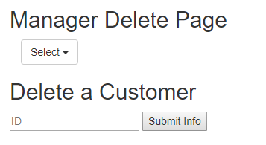

1. You can either delete an employee or a customer with an id.